Bahria University,

Karachi Campus



LAB EXPERIMENT NO.

___01___

LIST OF TASKS

|  |  |
| --- | --- |
| TASK NO | OBJECTIVE |
| 01 | Implement the following network on packet tracer.  Ping,   1. PC0 from PC5, 2. PC6 from PC2, 3. PC3 from PC1,   Also, display the above results in the simulation mode of packet tracer. Attach snapshots of the pinging results and the network created. |
|  |  |
|  |  |
|  |  |

Submitted On

27-09-2023

(Date: DD/MM/YY)

**Task 01:** Implement the following network on packet tracer.

Ping,

PC0 from PC5,

PC6 from PC2,

PC3 from PC1,

Also, display the above results in the simulation mode of packet tracer. Attach snapshots of the pinging results and the network created.

Complete the following table:

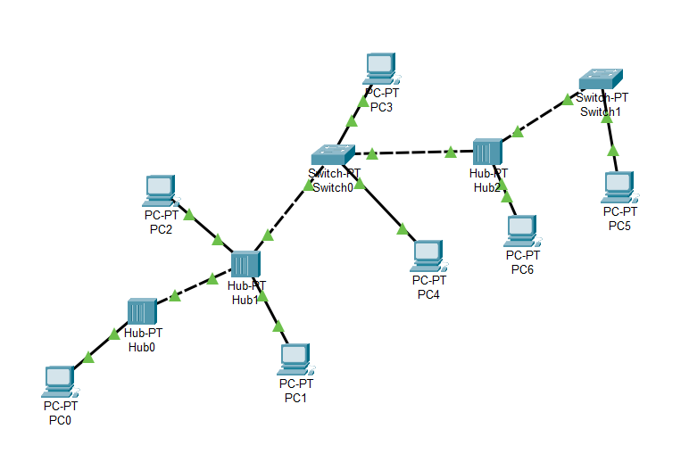

**Solution & Output:**

|  |  |
| --- | --- |
| End Device | IP Used |
| PC0 | 192.168.18.1 |
| PC1 | 192.168.18.3 |
| PC2 | 192.168.18.4 |
| PC3 | 192.168.18.6 |
| PC4 | 192.168.18.5 |
| PC5 | 192.168.18.2 |
| PC6 | 192.168.18.7 |

